|  |  |
| --- | --- |
| **Title** | **Page No.** |
| Table of Contents------------------------------------------- | 1 |
| Getting Started---------------------------------------------- | 3 |
| Website’s Overview---------------------------------------- | 5 |
| Live Chat----------------------------------------------------- | 7 |
| Admission---------------------------------------------------- | 9 |
| Gallery-------------------------------------------------------- | 11 |
| Operations Manual----------------------------------------- | 13 |
| Login----------------------------------------------------------- | 14 |
| Mange User-------------------------------------------------- | 18 |
| Manage Posts----------------------------------------------- | 21 |
| Manage Events--------------------------------------------- | 25 |
| Manage Comments---------------------------------------- | 27 |
| Manage Chat------------------------------------------------ | 28 |
| Websites Maintenance------------------------------------ | 29 |
| Installation Guide------------------------------------------- | 31 |

**TABLE OF CONTENTS**

|  |  |
| --- | --- |
| Hardware Specifications--------------------------------------- | 51 |
| Software Specifications---------------------------------------- | 52 |
| Hosting Requirements------------------------------------------ | 53 |

**GETTING STARTED**

1. Open a browser (ex. Google Chrome, Mozilla firefox, etc.)



1. At the address bar, simply type the **gallanosaofficial,** then click the **Website** at the right side of the screen.

**Laptop/Desktop screen**

**Mobile screen**

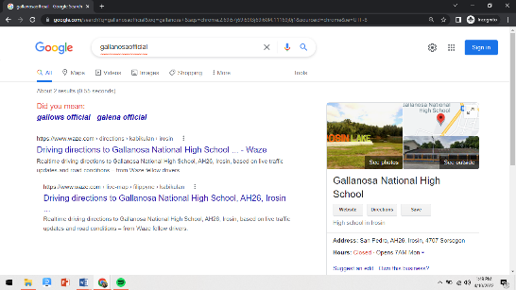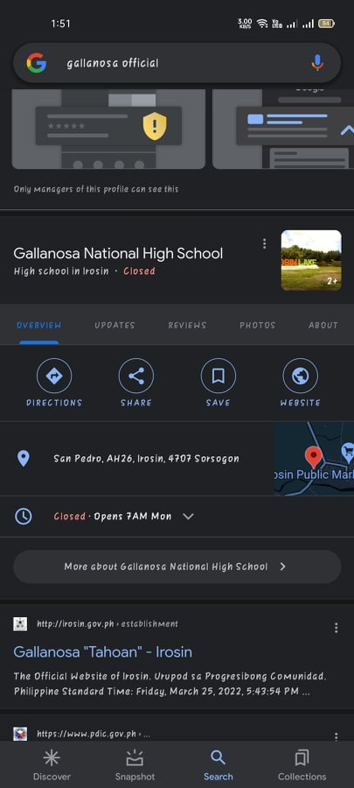

1. 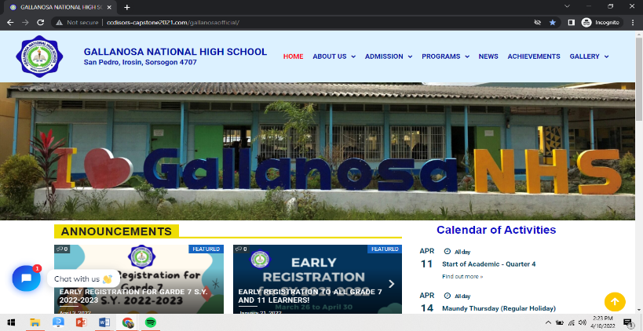In case you can’t find the number 2, in the address bar, type the **URL** of the website.

(https://bit.ly/gnhs-officialwebsite)

1. After you enter the URL, wait a minute until the homepage of the website displays on your screen.



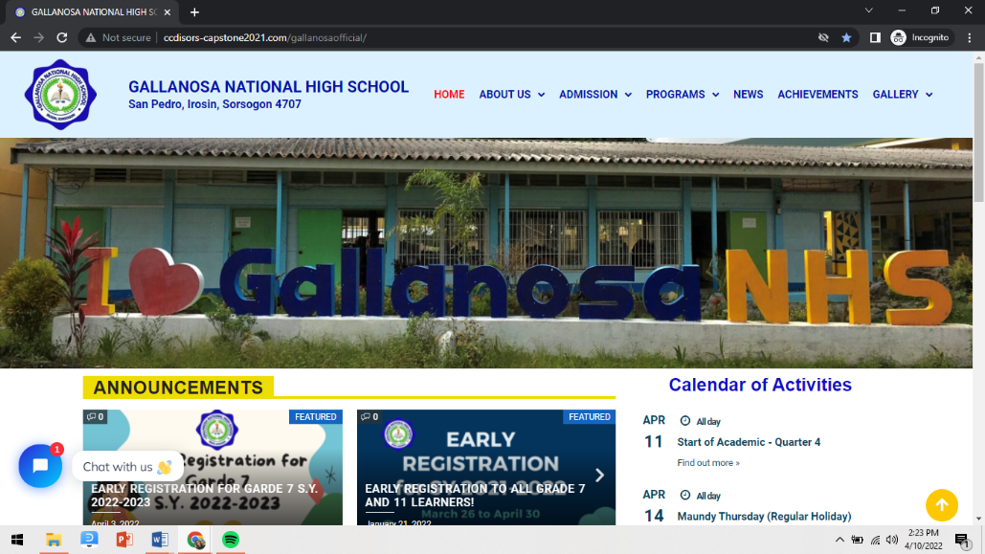 **WEBSITE’S OVERVIEW**

**1**

**2**

**3**

**4**

**5**

**6**

**7**

1. **HOME**

* Main webpage of the website. It displays the most important information or announcements about GNHS.
* It also includes the calendar of activities and recent news about the school.

1. **ABOUT US**

* It displays information about the GNHS, with the following submenus: **History**, **Contact Information**, **Organizational Chart**, **Calendar of Activities**, **Mission**, **Vision**, and **Core Values**, and **Officials and Personnel.**

1. **ADMISSION**

* It displays information about online registration for students wishing to enroll in GNHS, with the submenus **JHS REGISTRATION** and **SHS REGISTRATION.**

1. **PROGRAMS**

* This section displays the programs available for **Junior** and **Senior High School.**

1. **NEWS**

* This page displays the most important information that students and visitors should be aware of.

1. **ACHIEVEMENTS**

* This section highlights the accomplishments of GNHS students who have fought in other countries or even in our own country.

1. **GALLERY**

* This section contains photos and videos from various events at GNHS.

**LIVE CHAT**

1. 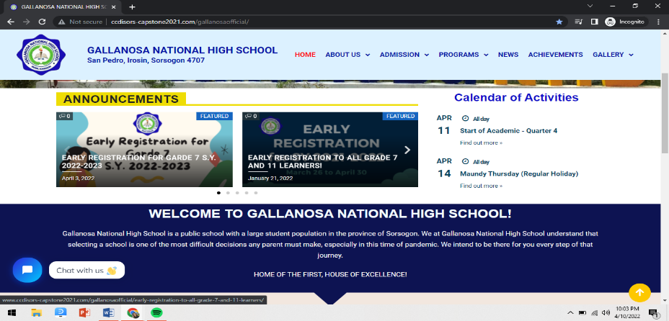On the left side of the screen, click the chat box.

That displays a "Chat with us" button.

1. Then type your concern for the school.
2. A pop-up message asks for your email address before the message is sent. As a result, the administrator's response will be sent to your email address.

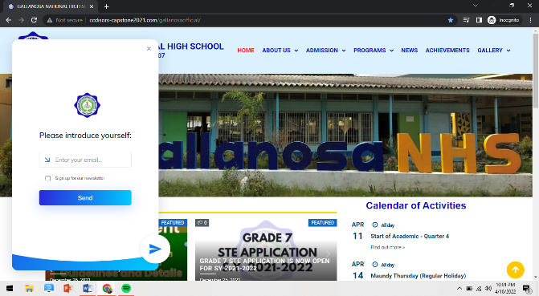

1. Wait for the admin's response after you send a message.

**NOTE:** If you see a message in the chat box that says **"We reply immediately"** (with a green dot or active status), it means the admin is online. If the message says, **"We typically reply within a few minutes,"** it means that the administrator is unavailable; simply wait for the administrator to respond.

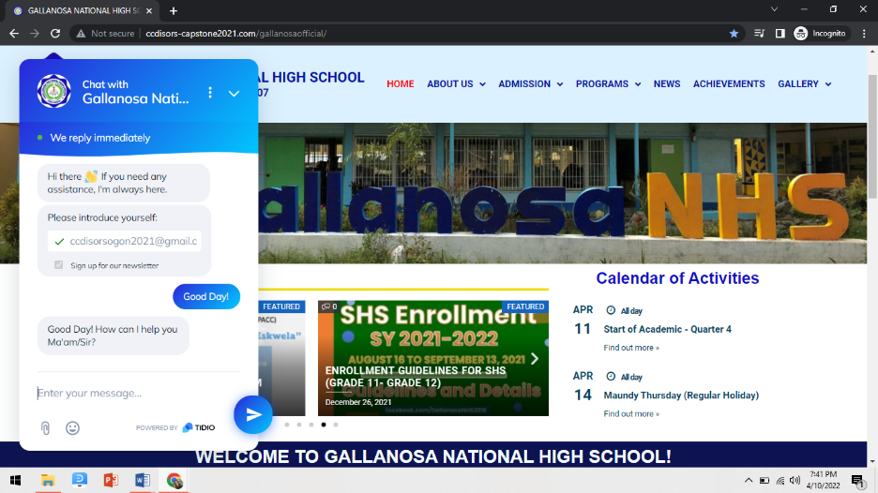

**ADMISSION**

1. On the page of Admission, it will contain the **JHS REGISTRATION** and **SHS REGISTRATION**.

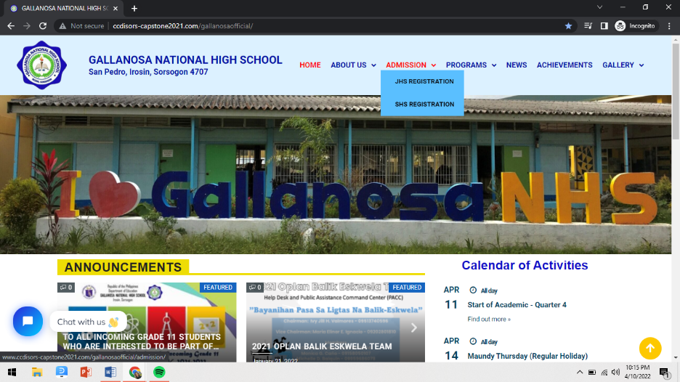

1. On the submenu of the Admissions page, click on **JHS REGISTRATION** if you’re going to register for junior

high school.

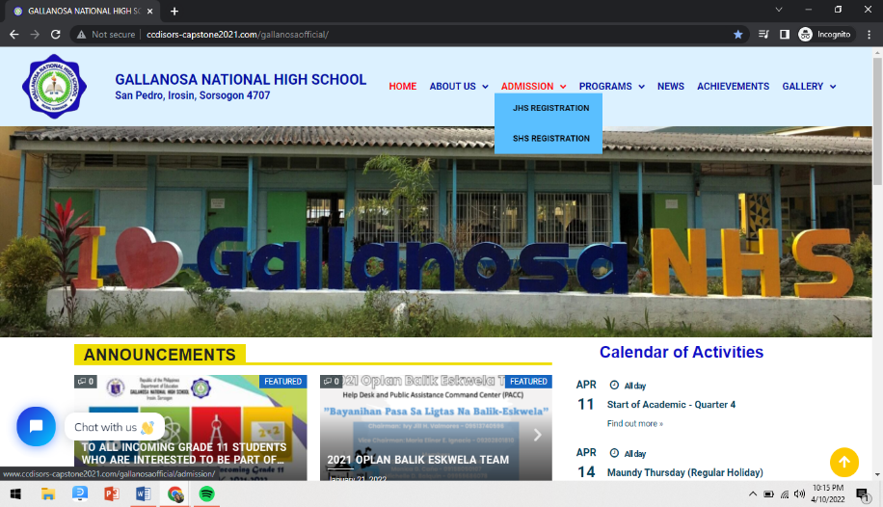

1. Then it will display the **ONLINE REGISTRATION PROCEDURE.**

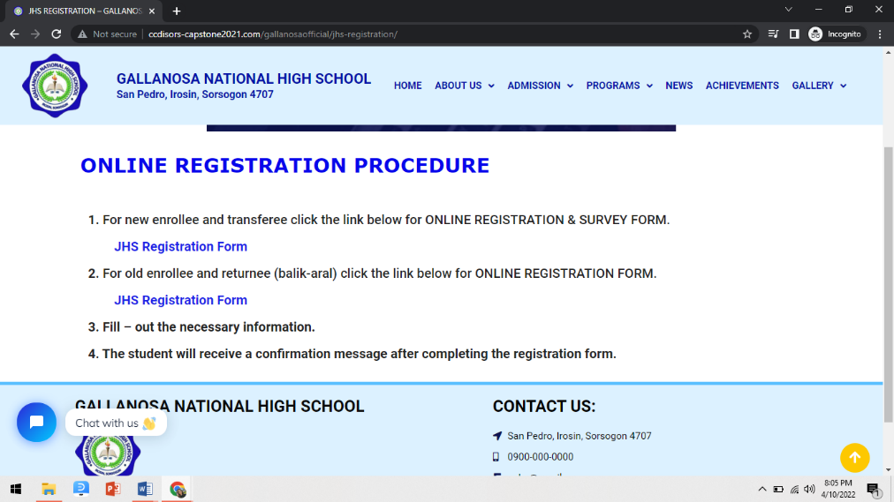

1. If you are a new enrollee, click the blue link below the procedure number 1. If you are an old enrollee or returnee, click the blue link below the procedure number 2.

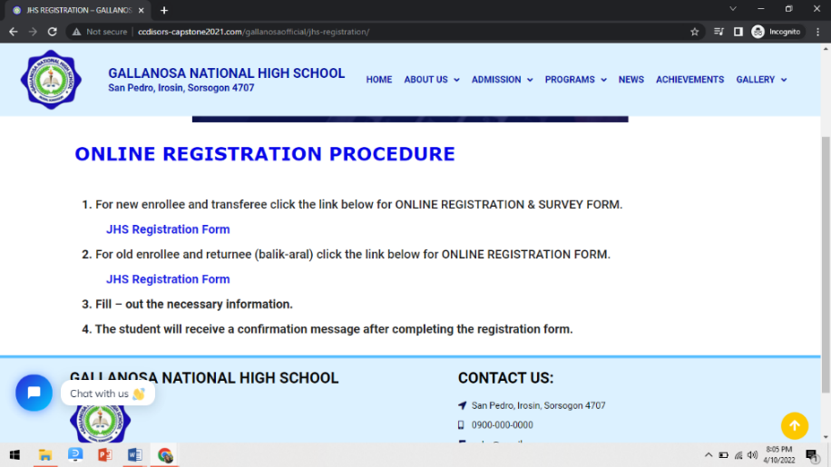

**GALLERY**

On the page of Gallery, it will contain the **PHOTOS**

and **VIDEOS** of Gallanosa National High School.

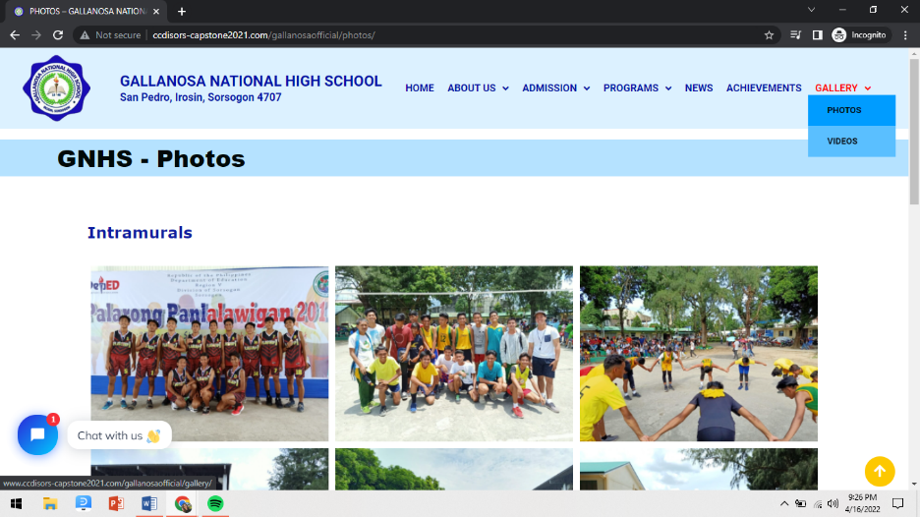

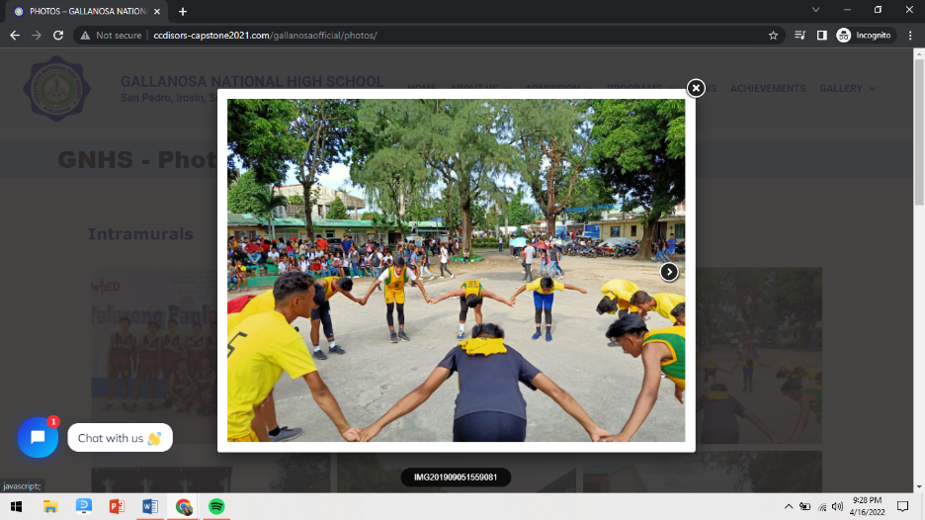 **PHOTO FEATURES**

**NEXT**

**EXIT**

**VIDEOS FEATURES**

**Dropdown for caption.**

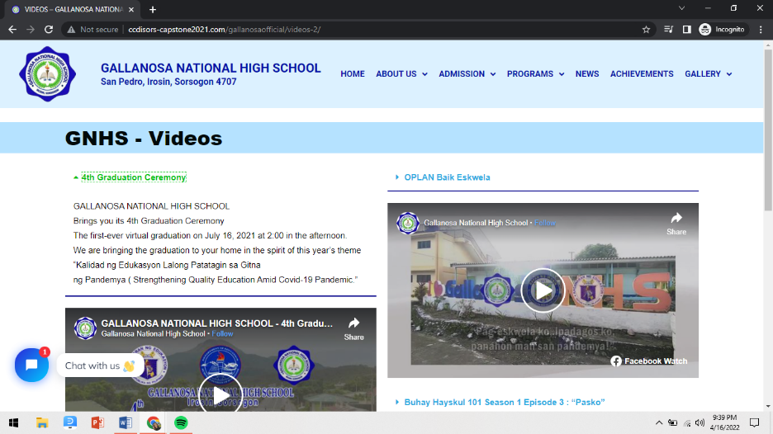

OPERATIONS

MANUAL



1. **Login**
2. **Administrator Account**
3. Open your browser and enter this link,

(https://bit.ly/gnhs-adminaccount)

1. Login to your account by providing your admin credentials. (username and password)

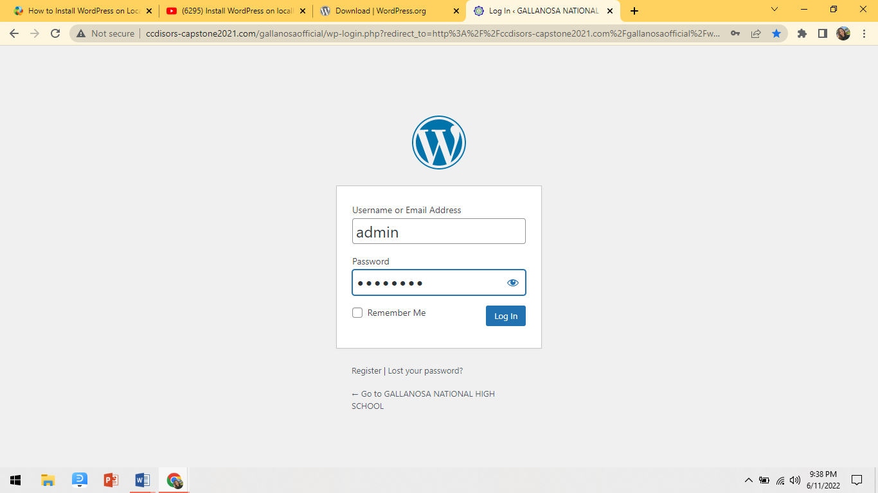

1. **Contributor Account**
2. Open your browser and enter this link, (https://bit.ly/gnhs-contributoraccount)
3. Login to your account by providing your admin credentials. (username and password)

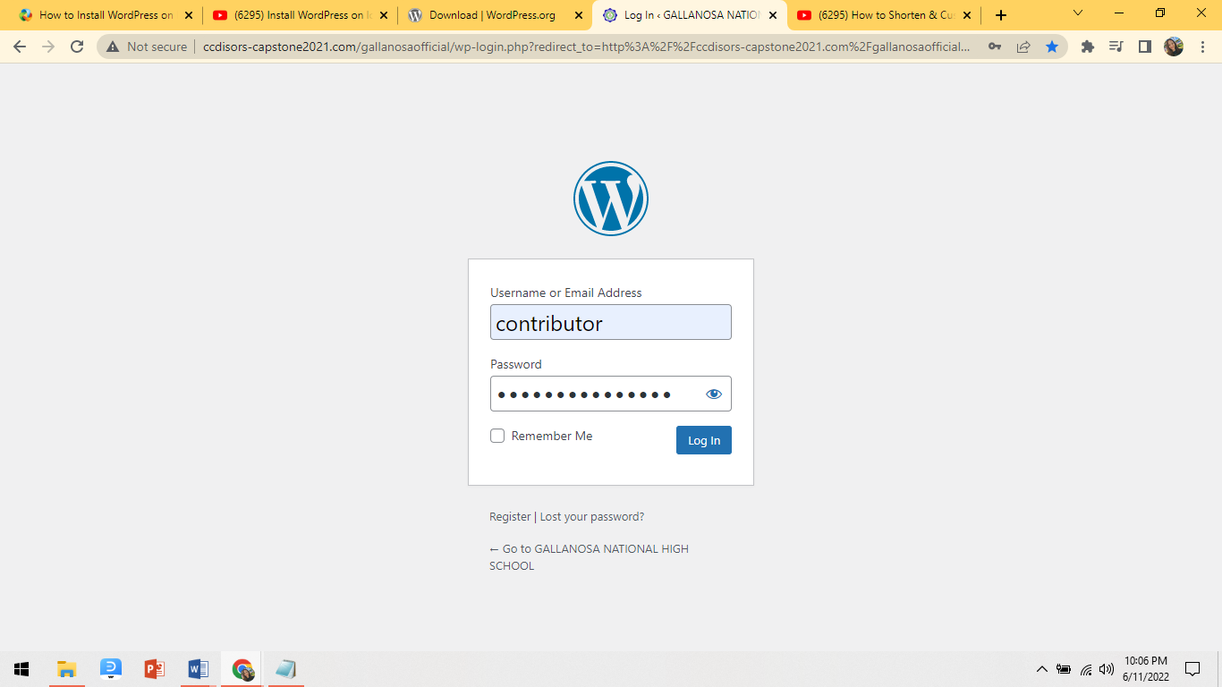

1. **Editor Account**
2. Open your browser and enter this link,

(https://bit.ly/gnhs-editoraccount)

1. Login to your account by providing your admin credentials. (username and password)

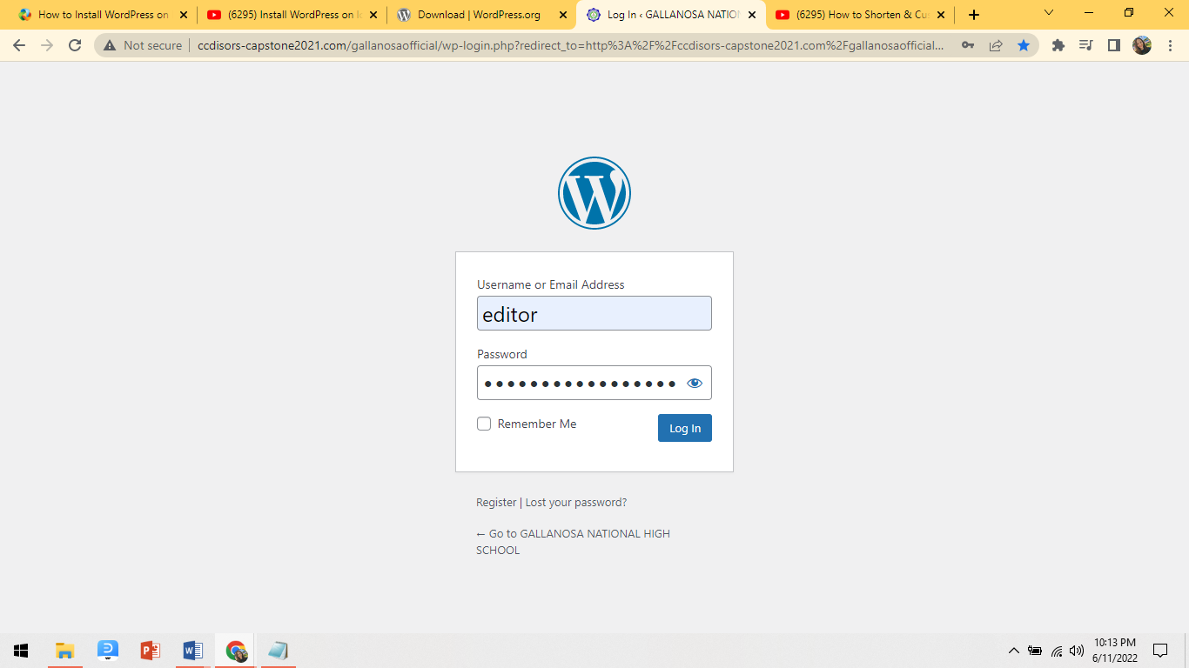

1. **Author Account**
2. Open your browser and enter this link, (https://bit.ly/gnhs-authoraccount)
3. Login to your account by providing your

admin credentials. (username and password)

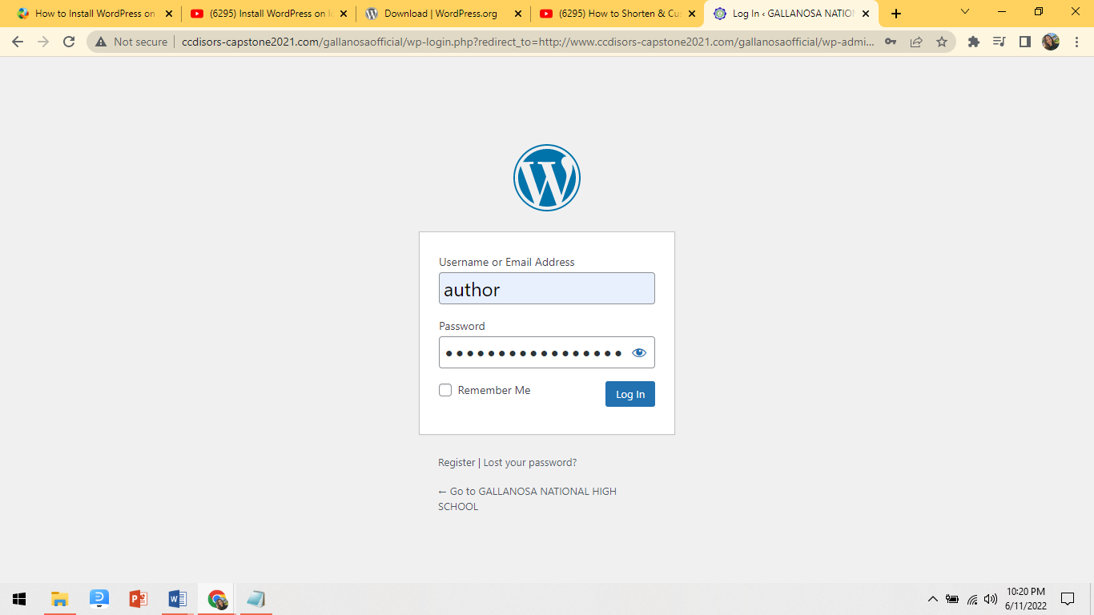

1. **Manage User**
2. To create a user account, first go to Users, then click Add New in the admin dashboard.

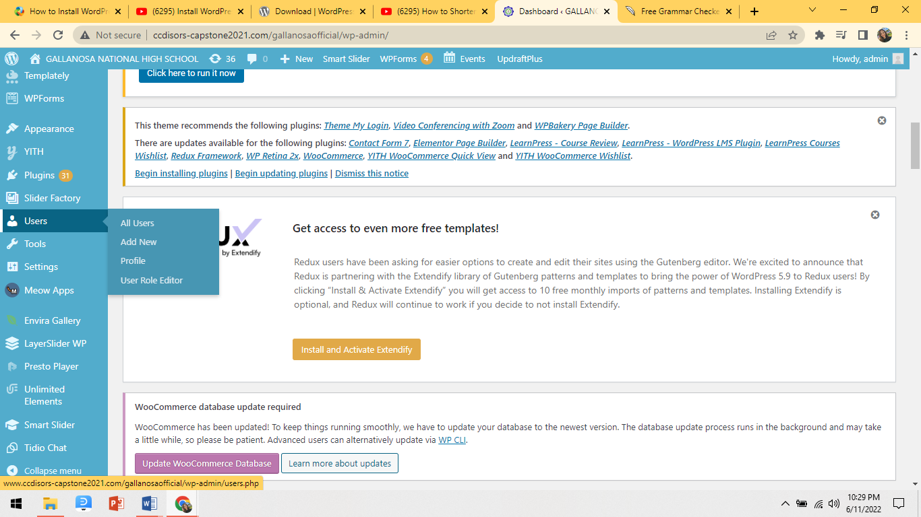

1. Next is to fill out the necessary information to create the account. Then in the Role section, select the user type. After choosing the user role, click Add New User at the bottom.

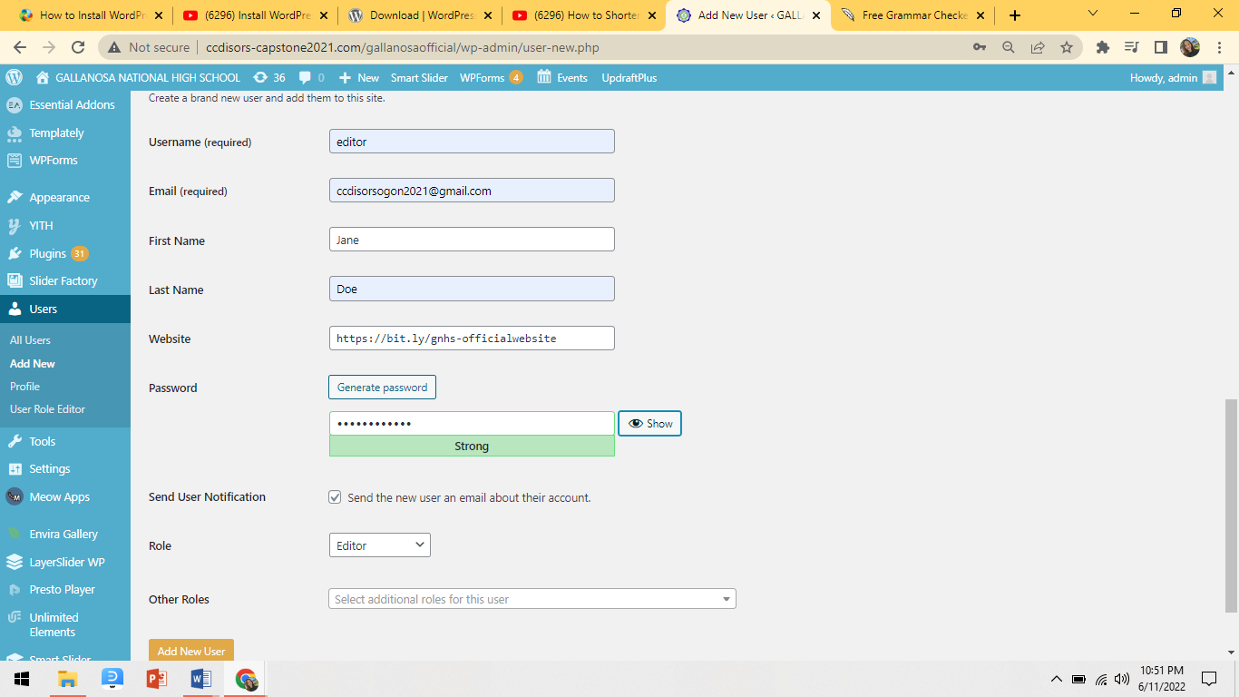

1. After adding the user, go to Users then All Users. 
2. 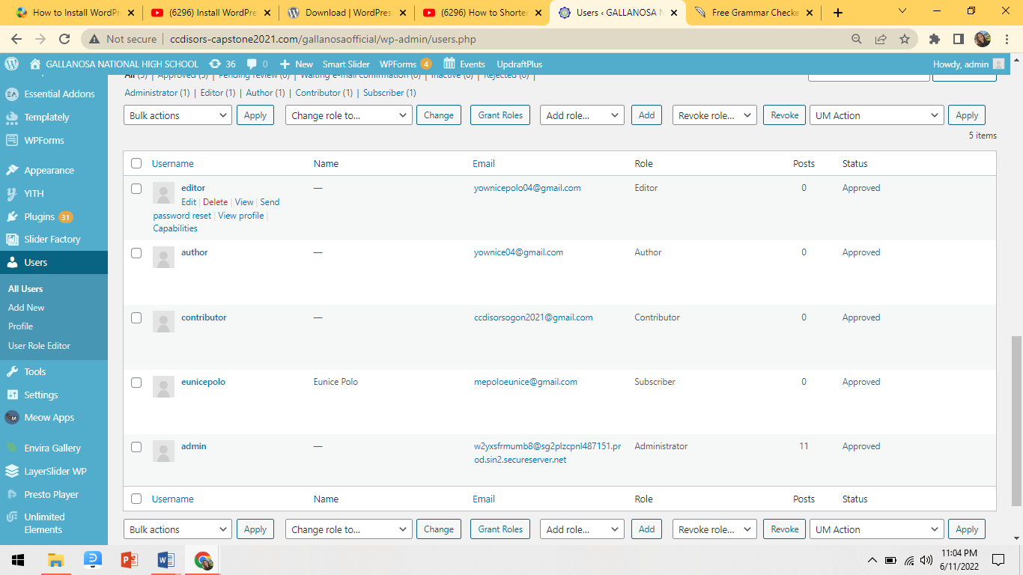On this dashboard it will show all the different users' accounts. It allows you to edit the profile of the user.
3. **Manage Posts**
4. Create Posts

1. To create Post, go to your dashboard click Posts

then click Add New.

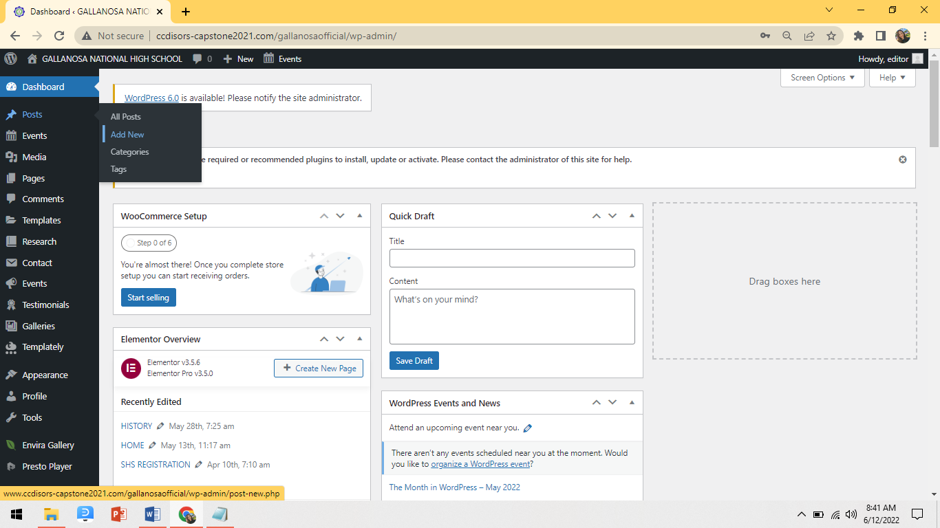

**1**

2. You can add the title of your post.

3. Type the details of your post.

4. This plus button is an additional widget that you can use to

add designs, images, videos, maps, etc. to your post.

1. In the category section, choose the type of post you

are creating, like news, featured, etc.

1. After you input all the details of your post, click the **"publish"** button so that your audience can see and read it.

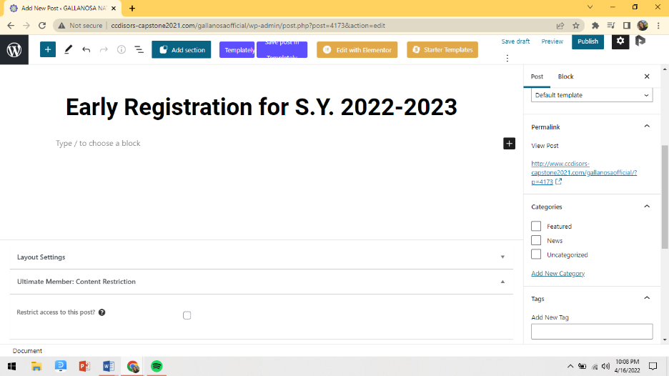

**6**

**5**

**2**

**4**

**3**

1. Edit Posts
2. Go to Posts >> All Posts

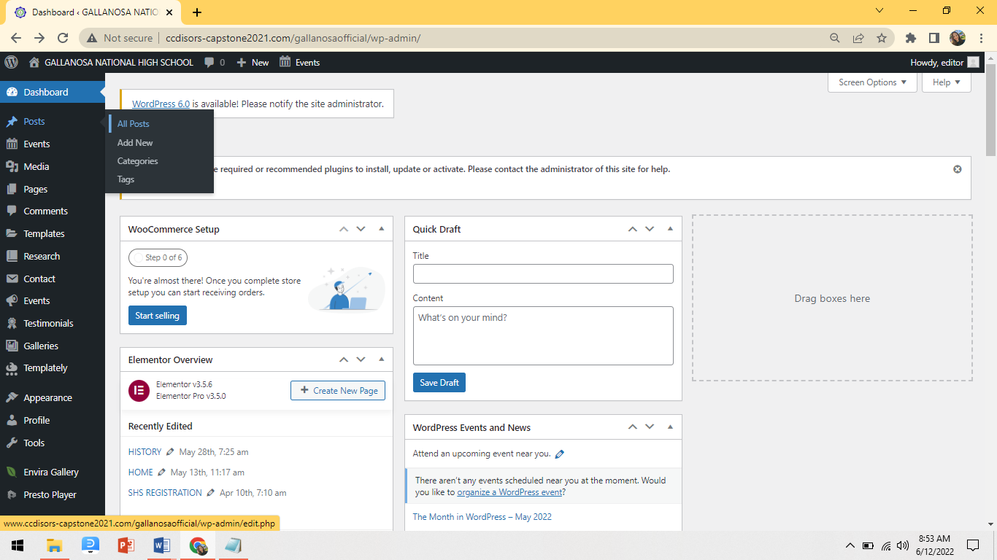

1. Select the posts that you want to edit by moving
2. the cursor near to their titles.
3. 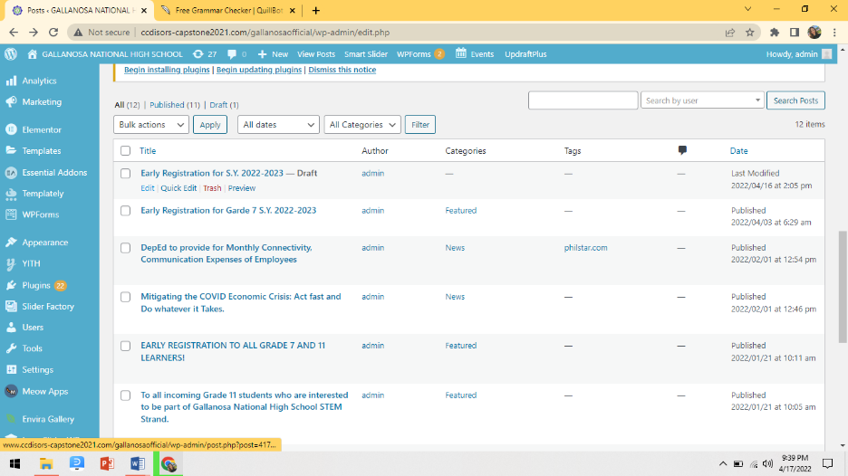Then click **Edit**.
4. You can now edit the post that you want and after it always click “**publish”** button to save your changes.
5. Create Categories
6. To create categories, go to post and then click categories.
7. Write the name of your category. The name of your category is how it appears on your site.
8. Write the slug of your category. Slug is the URL name of your category it appears in the last part of your website URL in the search box.
9. After that, click the button “**Add New Category”** in the bottom part of the category.

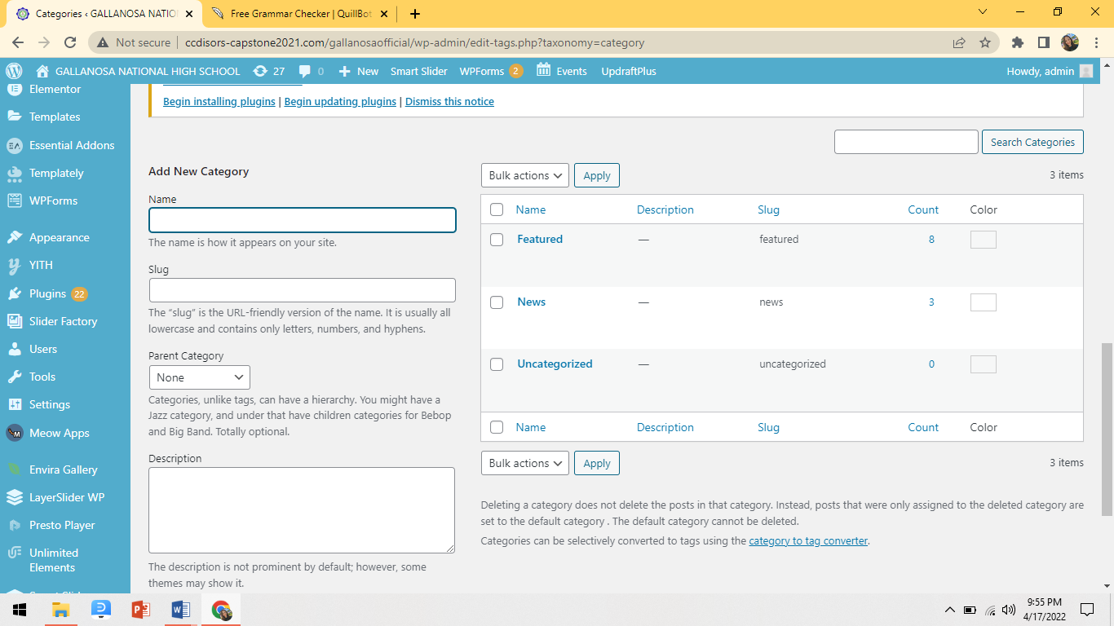

1. **Manage Events**
2. Add Events
3. 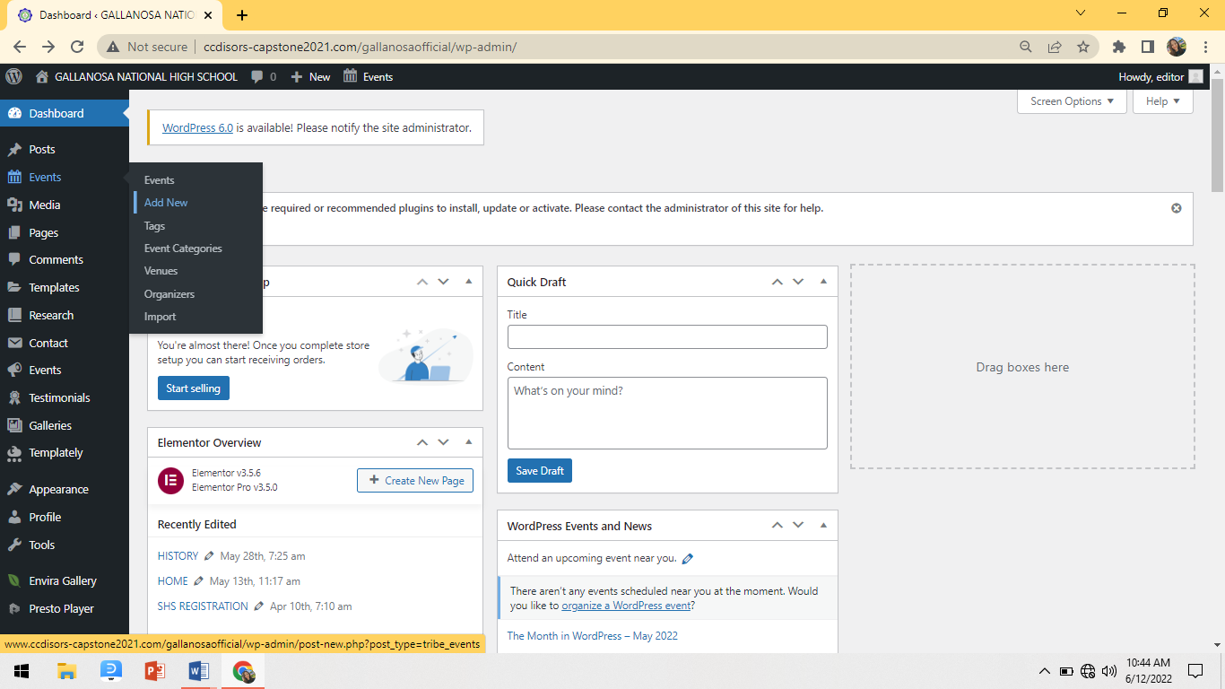Go to Events >> Add New

2. Put a title of your event.

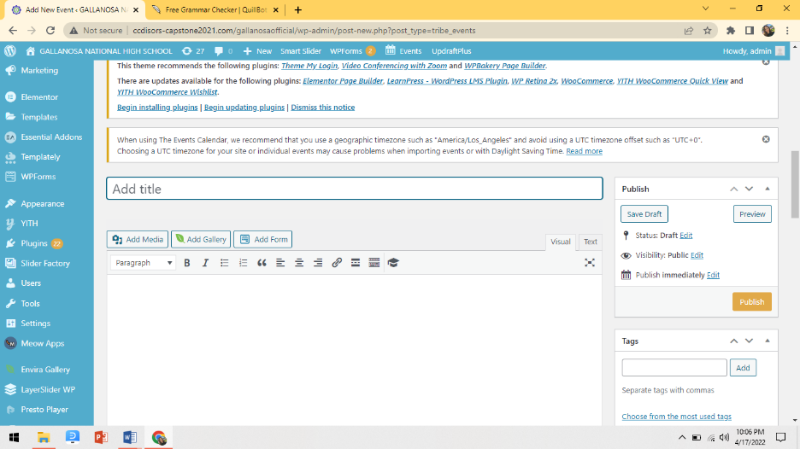

3. Write here a description of your title.

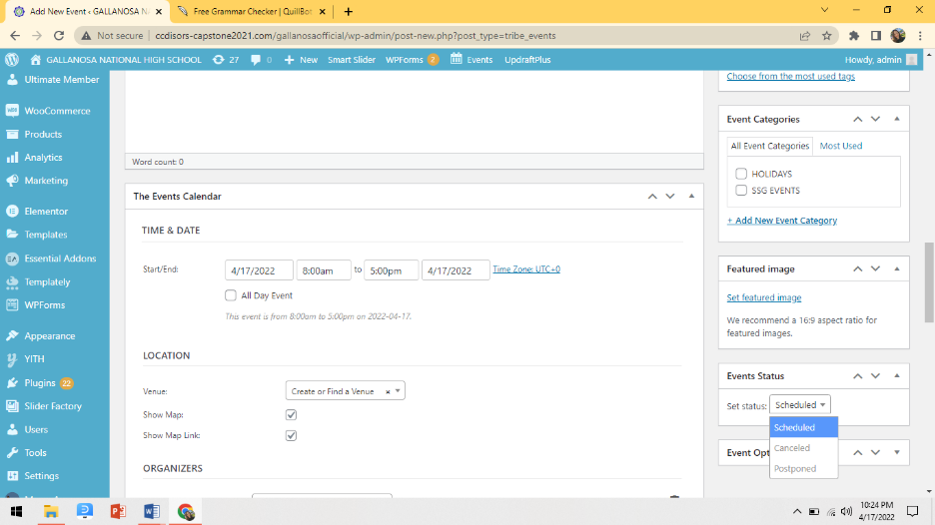4. Add Details on the event

**e**

**d**

**c**

**b**

**a**

1. Set here the date and time of the event to inform your audience when it will take place.
2. Choose a location for your event by clicking the drop-down button and choosing the venue you created to know where it will take place.
3. Pick an event category to separate each event at the school. For example, if the posted event is a holiday, a SSG event, etc.,
4. Choose an image to put in the featured image because it is a representative image of the article or event. And you can choose picture in your image gallery or you can upload a new one.
5. Here in event status, the visitor can identify whether the event is cancelled or postponed.
6. **Manage Comments**
7. Go to admin dashboard.
8. In the admin dashboard click the comment

section on the admin panel.

1. The panel will display the list of visitors' names, comments, and which post they commented on.
2. Below the comment, you can choose options like approved, reply, edit, mark as spam, or Delete.

Choose what you want to do in those comments.

Once you approve the comment, it will become

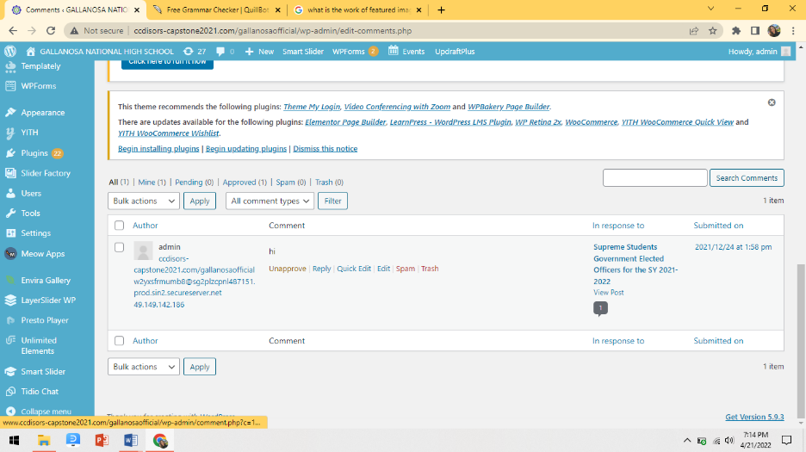visible on that specific post.

1. **Manage Chat**
2. In the administrator dashboard, go to tidio, located on the left side panel of the dashboard, and click "open tidio panel"; you will be directed to the login panel.
3. Login your Tidio Account.
4. On the left side of the Tidio panel, you can see the visitor's name and their message. You need to select their name to view and reply to their message. (See the pictures below)

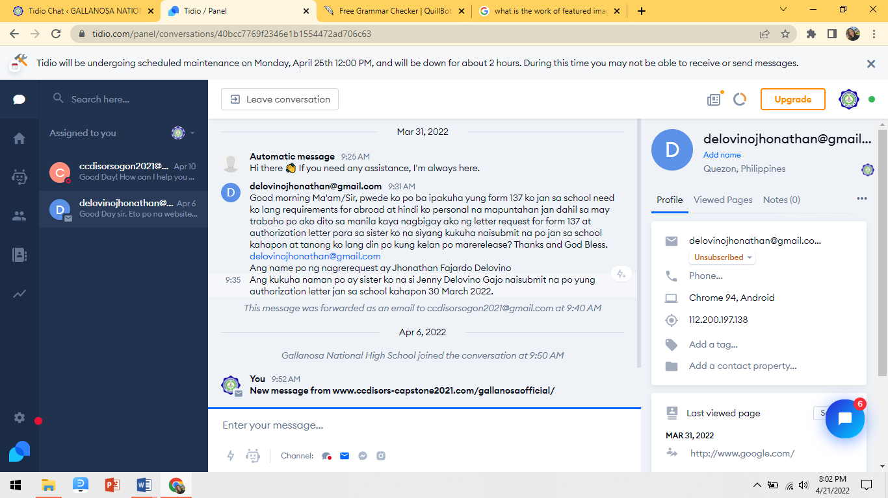

1. **Websites Maintenance**
2. **Create Backup**
3. To create backup go to settings and find the

**UpdraftPlus Backups** in the menu.

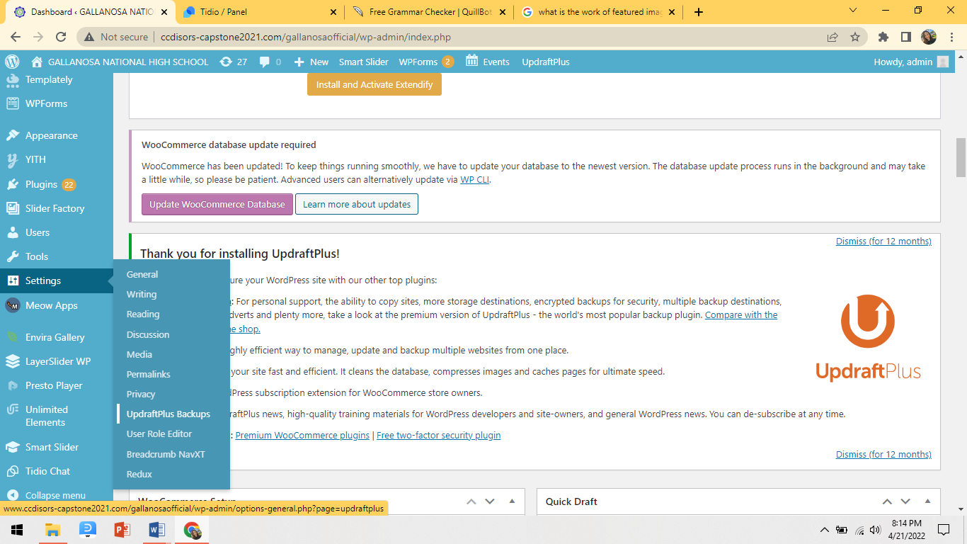

1. Then click the “**Backup Now”** Button.

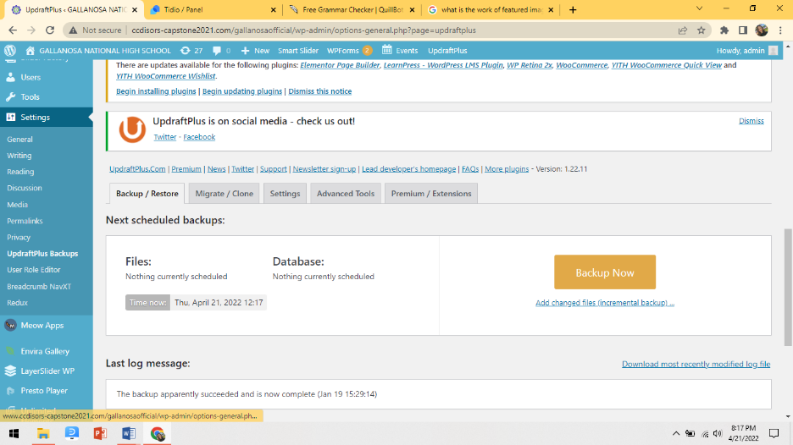

1. A pop-up message will appear and just only click the **“Backup Now”** and wait till the process is done.

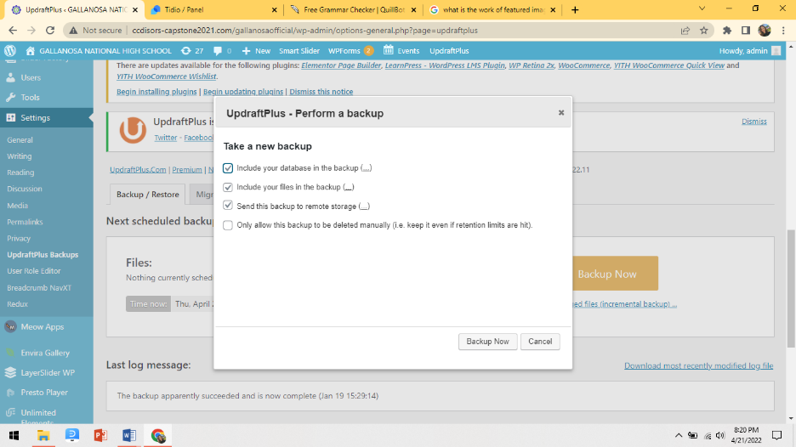

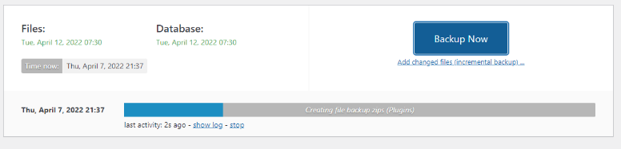

1. **Restore Backup files**
2. 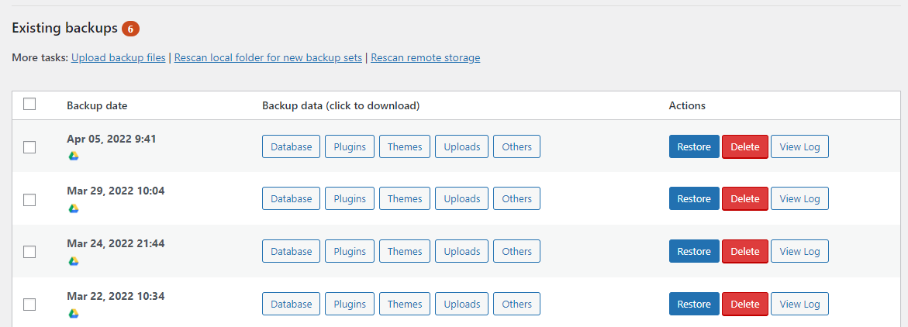To restore the backup file, just simply choose on what date of backup you want to restore.
3. **Installation Guide**

**HOW TO INSTALL WORDPRESS ON LOCAL HOST?**

**Step 1 – Download XAMPP**

* Simply go to [XAMPP's official website](https://www.apachefriends.org/index.html). Select your operating system and click on download button.
* Next is, click the download button.

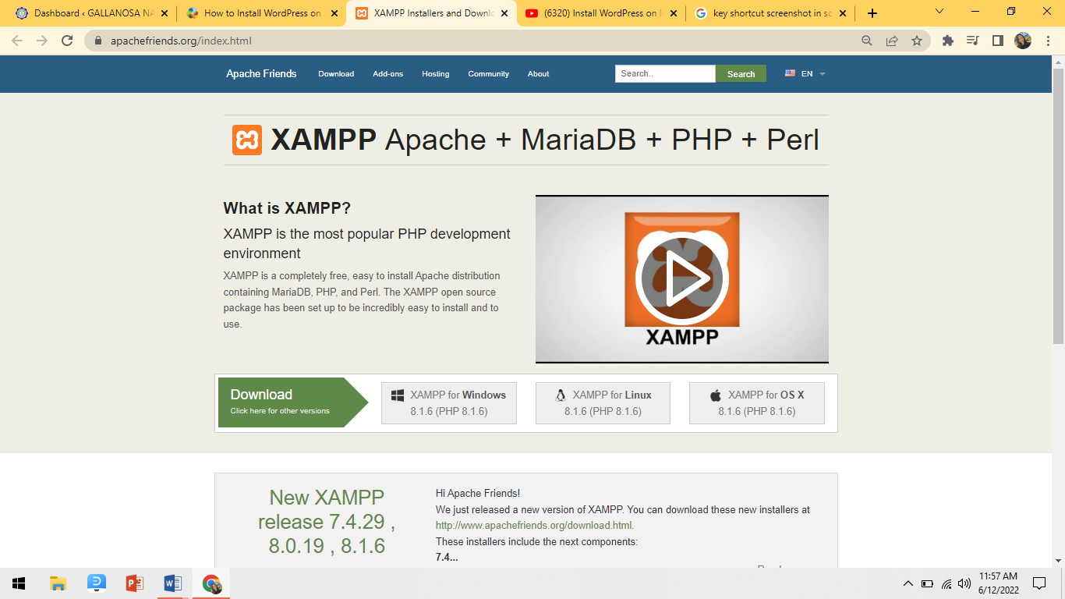

* Then choose the version that perfect for your device. (There are different versions for different operating systems.)

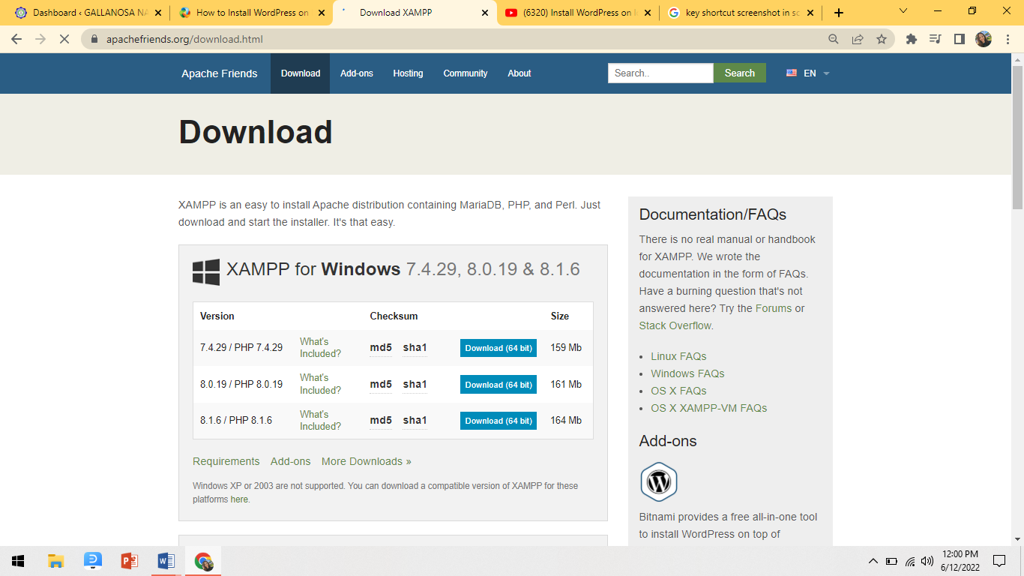

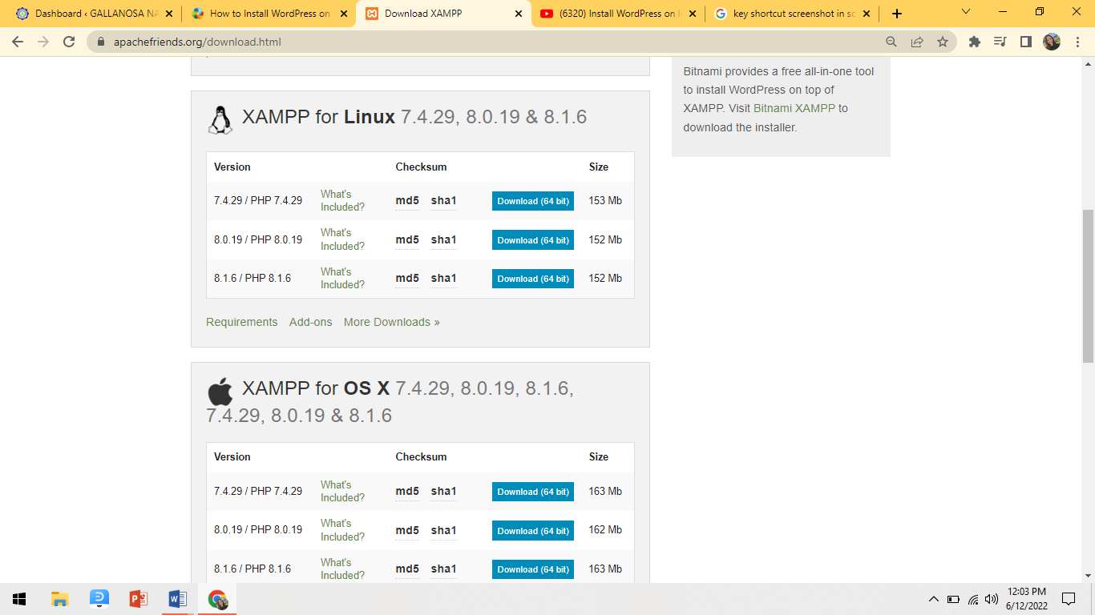

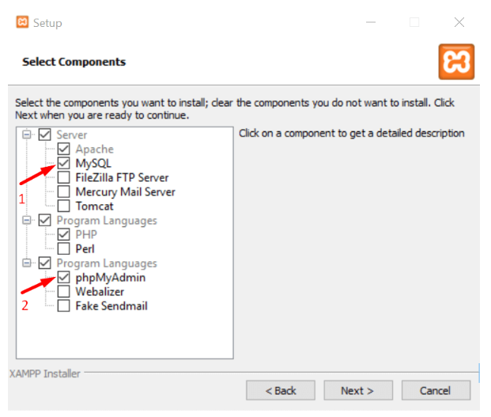 **Step 2 – Install & Run the XAMPP on Your PC**

* This is the second step. After downloading the

software, you need to unzip it. When the file

is ready, just select the Install button or click on

it twice. Soon you will discover that the installation

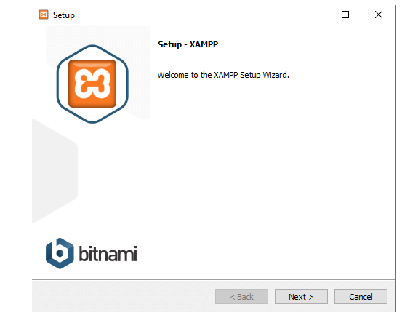process has begun.

* In the next step, you will see some checkboxes these

are already marked. You only need MySQL and

phpMyAdmin, so unmark all the others.

* After a few moments, you would see a welcome notice. That means your installation process is working perfectly.

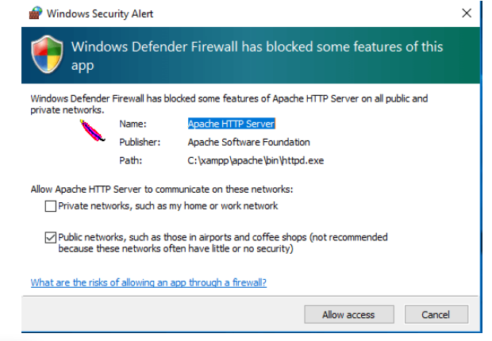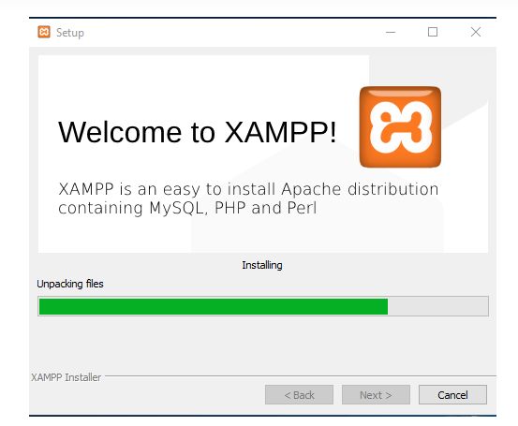

* If you have any antivirus software installed in your PC,

you may see a security alert like this. Don't worry,

check any of the given networks and go ahead by

clicking on the **Allow access** button.

* You would see a language selection option, check one that you want and click on the Save button.

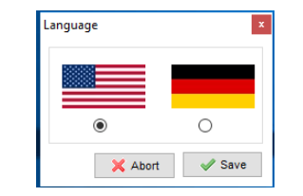

* You are almost at the end of the installation process.

Just mark this question box and click on **Finish**

button. The XAMPP control panel will automatically

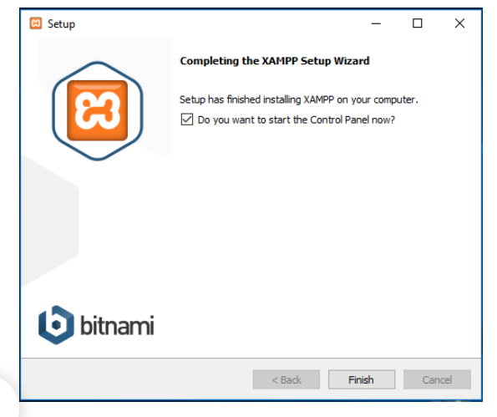run on your device.

**Congratulations! You have completed the XAMPP**

**installation process!**

**Step 3 – Download WordPress Latest Version**

Now is the time to create a database and start installing WordPress on localhost. To do that, you need to download the latest version of WordPress.

* Go to the [WordPress official website](https://wordpress.org/), click on Get WordPress button from the top right side. You will be redirected to a new page.
* 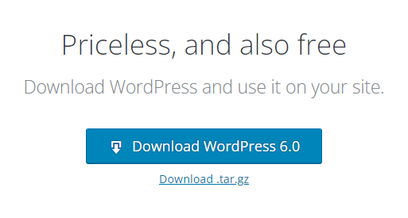Now hit on Download WordPress button.

The download process might take a few moments to begin. You will get a zip file. Unzip the file and copy that for your next uses.

**Step 4 – Create a Database**

To create a database, first you need to prepare a folder on

your PC in which you want to save all the data of your

local site.

* Go to your local disk, where you saved the downloaded XAMPP file.
* Select the **htdocs** folder and paste the WordPress latest version you have copied earlier.

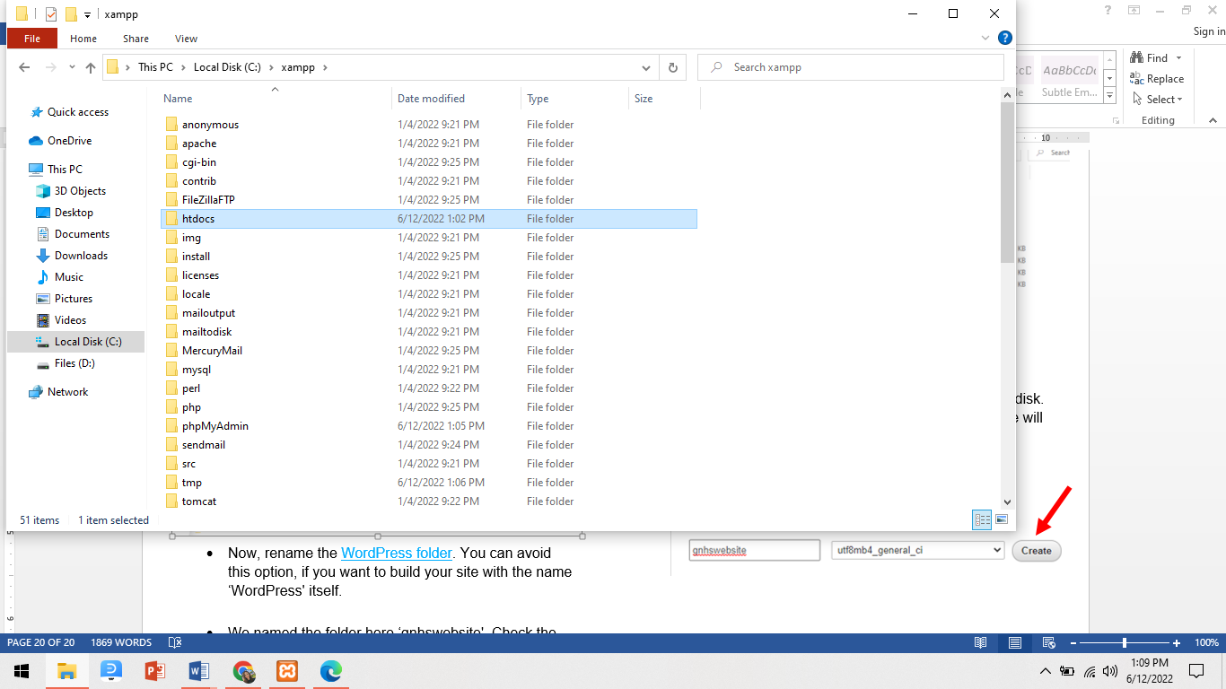

* Now, rename the [WordPress folder](https://wpevergreencontent.com/what-is-wordpress-learn-all-queires/). You can avoid this option, if you want to build your site with the name ‘WordPress' itself.
* 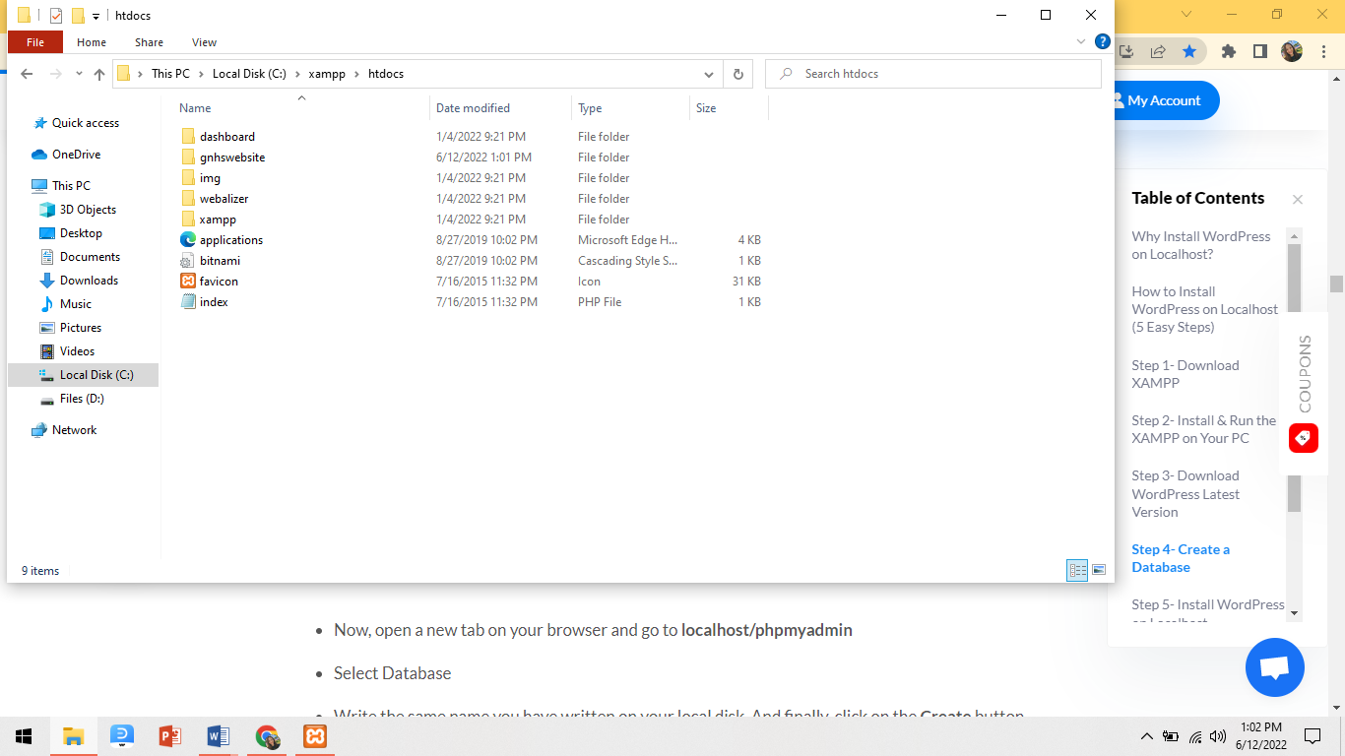We named the folder here ‘gnhswebsite'. Check the below screenshot. You should remember the name you have selected for your database.
* Now, open a new tab on your browser and go to **localhost/phpmyadmin**
* Select Database
* 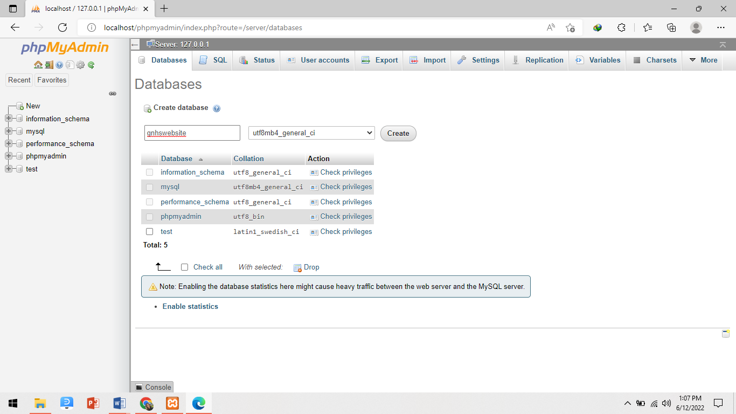Write the same name you have written on your local disk. And finally, click on the Create button. Your database will be created within a few seconds.

You have successfully created your localhost database. Now, is the turn to install [WordPress](https://sakiladnan.com/books/) on the localhost.

**Step 5 – Install WordPress on Localhost**

* Open a new tab on your browser and write

localhost/your given name (‘gnhswebsite‘ in our case)

and hit on the **Enter** button. You

will see a WordPress setup wizard like below.

* Select your language and click on continue.

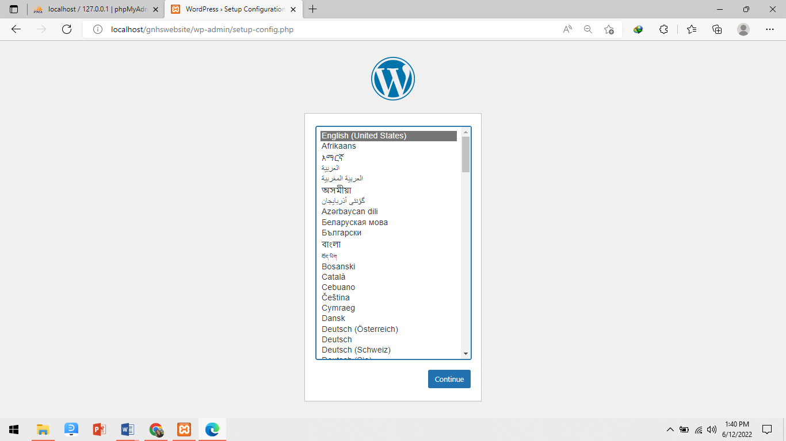

* You would see a welcome notice on behalf of WordPress. On the next step, WordPress will require

1. A database Name
2. A user name
3. A password
4. And a database host

* 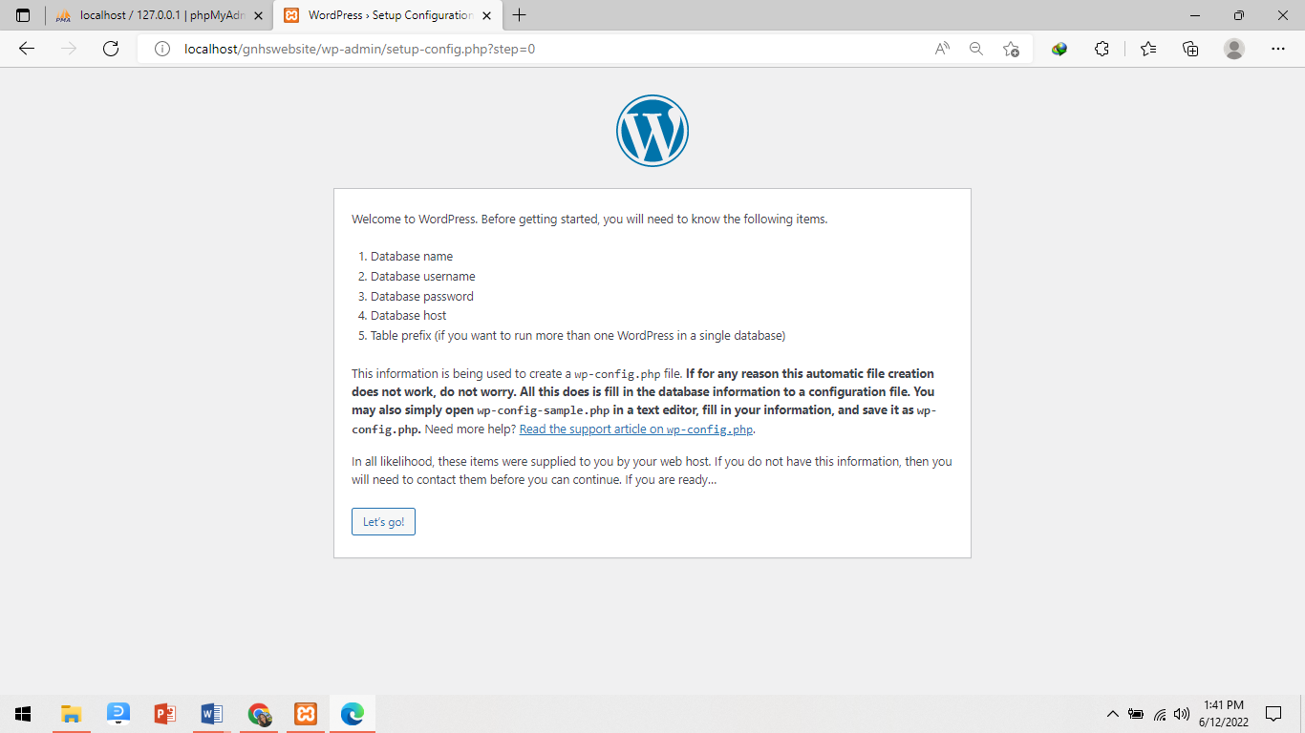Just click on the Let's go button
* These are the fields you can see in the below screenshot.
* Provide your database name, you can write ‘root' as user name, keep the password option blank- it's better and you would find other fields filled up from earlier.
* Click on Submit button.
* 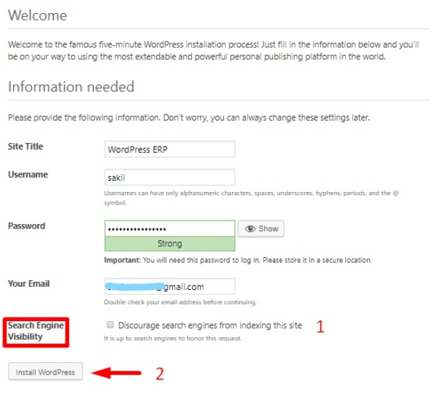This is your final step of installation.
* 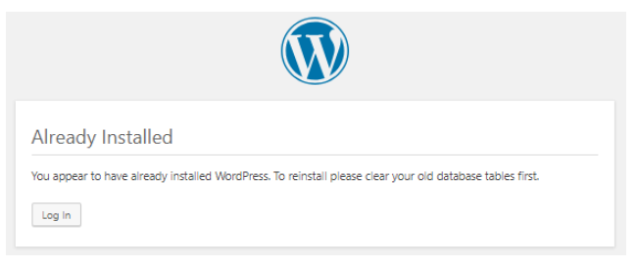Give a name to your site. we named our site  [WordPress ERP](https://wperp.com/) here. You can also keep your database name as your site's name.

1. Write your user name
2. Give a strong password
3. Write your personal e-mail address
4. Carefully check the search engine visibility button. Otherwise, Google would start indexing your local site too!

* And, finally click on Install WordPress button!

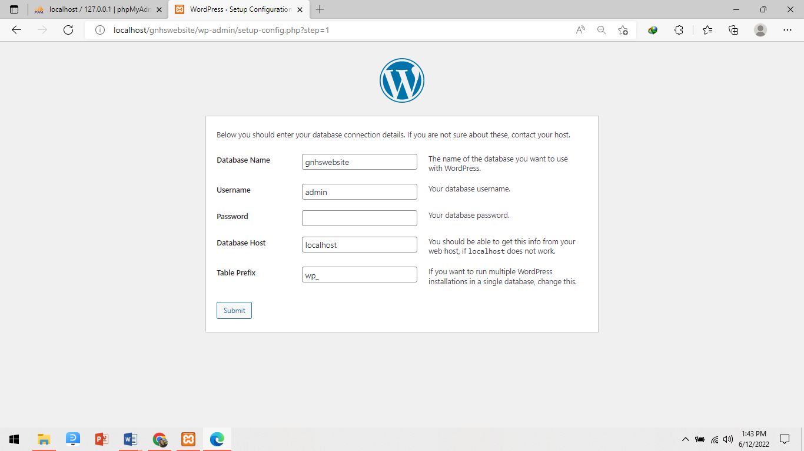

**How to deploy WordPress site into a hosing?**

**Step 1 – Install WordPress on my Linux-hosted domain using cPanel**

* In our case we choose godaddy.com as our web hosting.
* 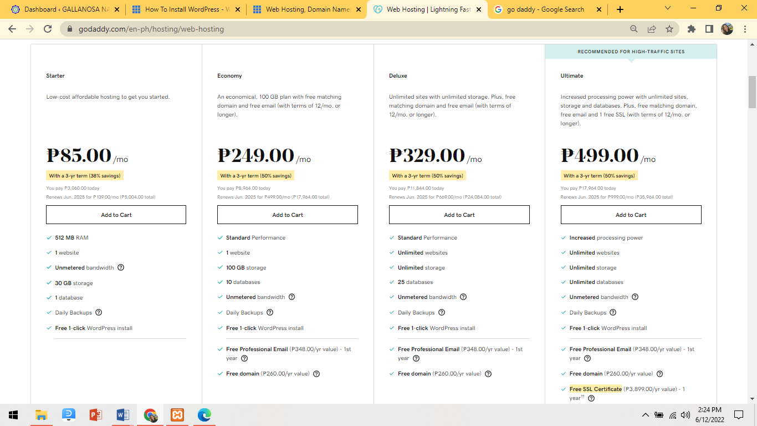You’ll need to pay for the chosen web hosting for you to have a web hosting account.
  1. Now, if you have already created an account, log in to your web hosting account.

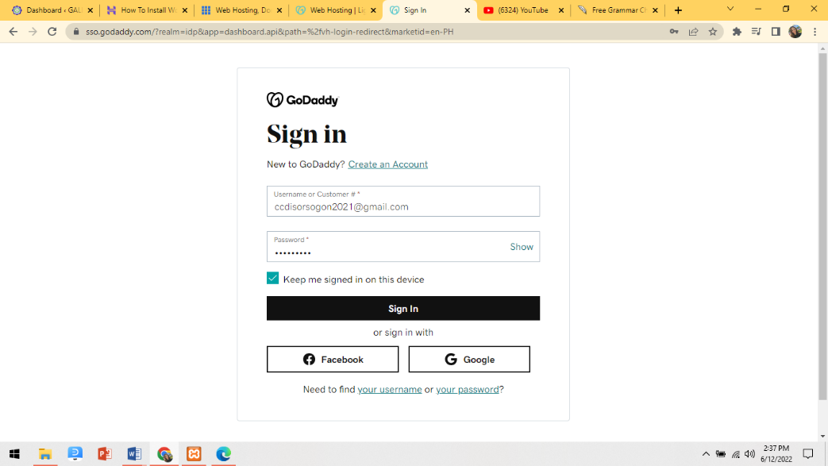

* If you want to use WordPress to build your website and blog, you have to first install it on your hosting account.

1. 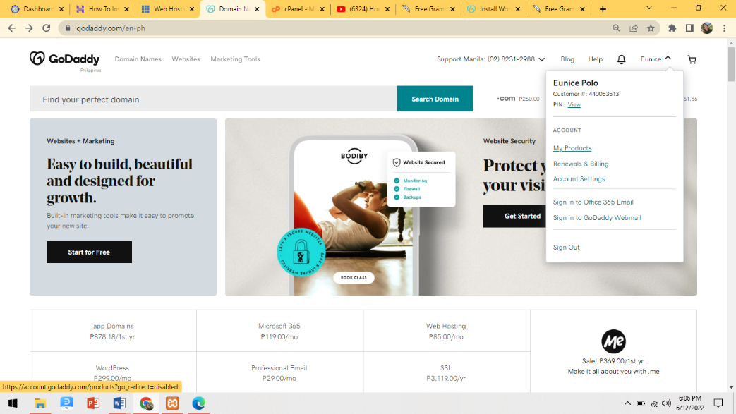Go to your GoDaddy [product page](https://account.godaddy.com/products/).
2. Under **Web Hosting**, next to the Linux Hosting account you want to use, select **Manage**.

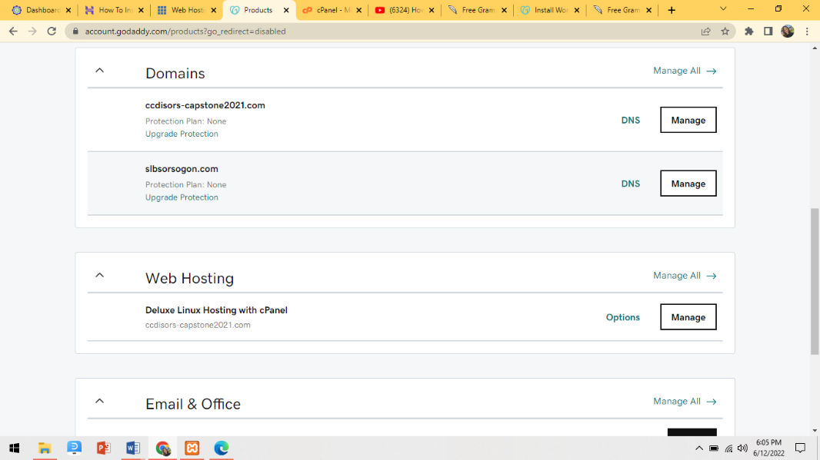

1. In the account **Dashboard**, in the **Websites** section, below the domain where you want to install WordPress select **Install Application**. We'll take you to the Installation **Applications Browser** page.

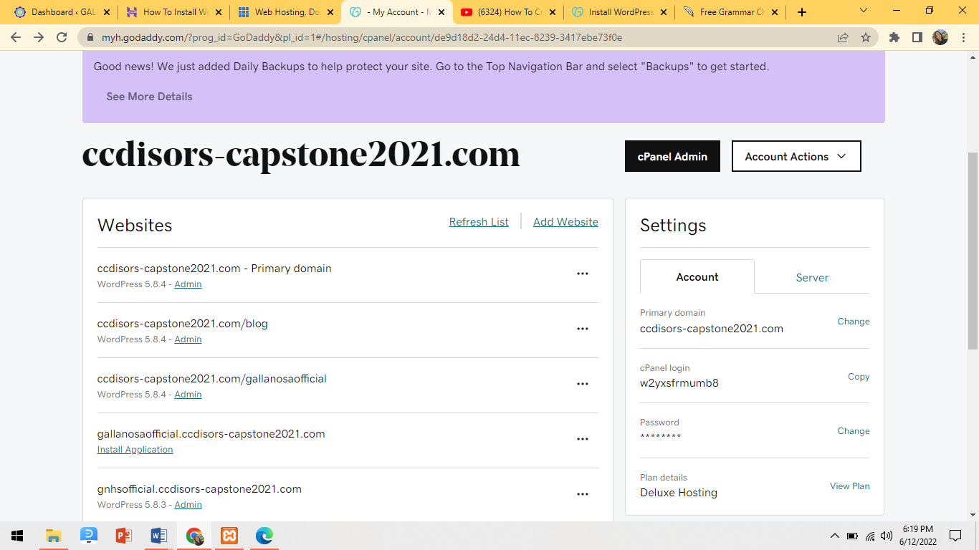

1. Click Add Website to create a domain name.
2. Complete the following fields, and then select **Install**:

**Step 2 – Sign in to WordPress**

Here’s how to sign in to WordPress to start editing your site.

1. In a browser, go to **http://[**your WordPress domain

name**]/wp-admin** (for example, <https://bit.ly/gnhs-admin>).

2. Enter your **Username or Email Address** and

**Password**, then select **Log In**.

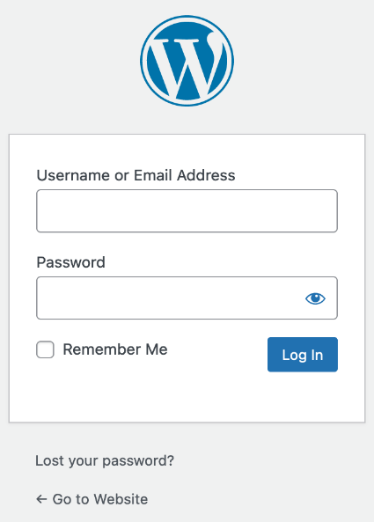

3. Once you’ve done that, log in. You can see your dashboard, and then you can design your website.

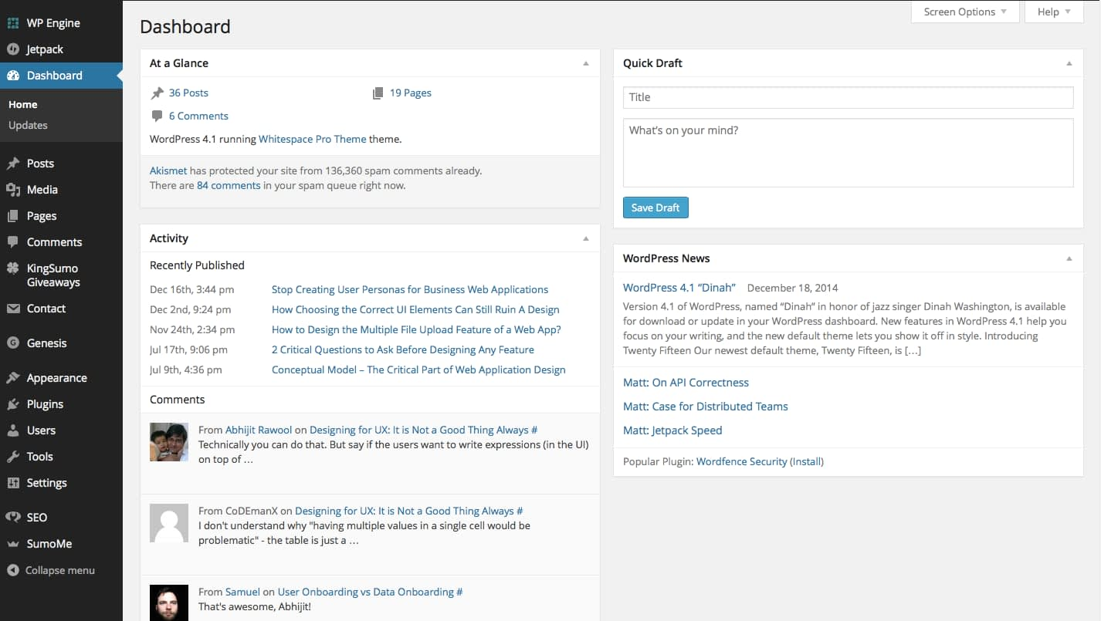

1. **Hardware Specifications**

* The recommended use in hardware specifications

for **clients** to create the website is:

|  |  |
| --- | --- |
| Description | Minimum Requirements |
| Monitor | 1024x7268 resolution |
| Processor | Intel® Pentium® Dual Core 1.1 GHz |
| Ram | 2 GB |
| Hard Disk | 32 GB |

* Here’s the recommended specification if you want

to have a fastest process on the PC or laptop.

|  |  |
| --- | --- |
| Description | Recommended |
| Monitor | 1366x768 resolution |
| Processor | Intel® Pentium® Dual Core i3 or higher |
| Ram | 4 GB or higher |
| Hard Disk | * + 1. or higher |

1. **Software Specifications**

* The recommended use in software specifications for **clients** to create the website is:

|  |  |
| --- | --- |
| Description | Recommended |
| Browser | Google Chrome Version 97.0.4692.99/ Any equivalent browser |

* The recommended use in software specifications for **server** to create the website is:

|  |  |
| --- | --- |
| Description | Recommended |
| Operating System | Windows 10 |
| Apache | Apache 2.4 |
| Wordpress | 5.8.4 or higher |
| GoDaddy (Domain Name and Web  Hosting) | Deluxe Plan |
| RAM | 8 GB or higher |
| Hard Disk | 500 GB or higher |

1. **Hosting Requirements**

* Here is the recommended use in hosting

requirements and also the latest version of

hosting requirements.

|  |  |
| --- | --- |
| Description | Recommended |
| Bandwidth | Unmetered |
| Database | PHP 7.4 |
| MySQL | MySQL 5.6 |
| Security | SSL |